Load Test Report

## Load Details

Stack: S1

Stack Url: https://jupiter.uptycs.net/

Sprint: 138

Build: 138005

Load Name: ControlPlane

Load Duration In Hrs: 10 hrs

Load Start Time Ist: 2023-09-04 00:33

Load End Time Ist: 2023-09-04 10:33

Customer: Single

Total Assets: 200K

### Test Environment details

|  |  |  |  |  |
| --- | --- | --- | --- | --- |
| node | cluster | cores | ram | storage |
| s1c1pn1 | 1 | 32 | 188 | root_partition:365G, kafka:3.6T, |
| s1c1pn2 | 1 | 32 | 188 | root_partition:365G, kafka:3.6T, |
| s1c1pn3 | 1 | 32 | 188 | root_partition:365G, kafka:3.6T, |
| s1c1pn4 | 1 | 32 | 188 | root_partition:365G, kafka:3.6T, |
| s1c1pn5 | 1 | 32 | 188 | root_partition:365G, kafka:3.6T, |
| s1c1pn6 | 1 | 32 | 188 | root_partition:365G, kafka:3.6T, |
| s1c2pn1 | 2 | 32 | 188 | root_partition:365G, kafka:3.6T, |
| s1c2pn2 | 2 | 32 | 188 | root_partition:365G, kafka:3.6T, |
| s1c2pn3 | 2 | 32 | 188 | root_partition:365G, kafka:3.6T, |
| s1c2pn4 | 2 | 32 | 188 | root_partition:365G, kafka:3.6T, |
| s1c2pn5 | 2 | 32 | 188 | root_partition:365G, kafka:3.6T, |
| s1c2pn6 | 2 | 32 | 188 | root_partition:365G, kafka:3.6T, |
| s1c1dn1 | 1 | 32 | 251 | root_partition:365G, spark:3.6T, dn1:3.6T, dn2:3.6T, dn3:3.6T, |
| s1c1dn2 | 1 | 32 | 251 | root_partition:365G, spark:3.6T, dn1:3.6T, dn2:3.6T, dn3:3.6T, |
| s1c1dn3 | 1 | 32 | 251 | root_partition:365G, spark:3.6T, dn1:3.6T, dn2:3.6T, dn3:3.6T, |
| s1c1dn4 | 1 | 32 | 188 | root_partition:365G, spark:3.6T, dn1:3.6T, dn2:3.6T, dn3:3.6T, |
| s1c1dn5 | 1 | 32 | 188 | root_partition:365G, spark:3.6T, dn1:3.6T, dn2:3.6T, dn3:3.6T, |
| s1c1dn6 | 1 | 32 | 188 | root_partition:365G, spark:3.6T, dn1:3.6T, dn2:3.6T, dn3:3.6T, |
| s1c2dn1 | 2 | 32 | 251 | root_partition:365G, spark:3.6T, dn1:3.6T, dn2:3.6T, dn3:3.6T, |
| s1c2dn2 | 2 | 32 | 251 | root_partition:365G, spark:3.6T, dn1:3.6T, dn2:3.6T, dn3:3.6T, |
| s1c2dn3 | 2 | 32 | 251 | root_partition:365G, spark:3.6T, dn1:3.6T, dn2:3.6T, dn3:3.6T, |
| s1c2dn4 | 2 | 32 | 188 | root_partition:365G, spark:3.6T, dn1:3.6T, dn2:3.6T, dn3:3.6T, |
| s1c2dn5 | 2 | 32 | 188 | root_partition:365G, spark:3.6T, dn1:3.6T, dn2:3.6T, dn3:3.6T, |
| s1c2dn6 | 2 | 32 | 188 | root_partition:365G, spark:3.6T, dn1:3.6T, dn2:3.6T, dn3:3.6T, |
| s1configdb1 | 1 | 32 | 188 | root_partition:365G, pg:3.5T, data:3.5T, |
| s1configdb2 | 1 | 32 | 188 | root_partition:365G, pg:5.5T, data:5.5T, |
| s1monitor | 1 | 16 | 62 | root_partition:98G, |

### Kafka topics

|  |
| --- |
| 138005 |
| Summary : New topics found |
| New Topics : __consumer_offsets __debezium-heartbeat.cdc __debezium-heartbeat.statedb agentghquery agentkubequery agentlesslog agentlesslogdecorator agentoktaquery agentosquery alert alert_replay api asset-capability assetgroup1 audit auto-exception az_events_blob bulk_replay cdc.public.alerts cdc.public.asset_cloud_infos cdc.public.asset_tags cdc.public.assets cdc.public.cloud_accounts cdc.public.customer_database cdc.public.customers cdc.public.incidents cdc.public.object_groups cdc.public.user_object_groups cdc.public.users cloudconnectorsink cloudqueryVuln cloudqueryevents cloudqueryinventory cloudtrail_objects compliance compliance_summary containers cqazevents cqcloudtrail cqcloudtrail_data_sink cqcloudtrail_ro_sink debezium_configs debezium_offsets debezium_statedb_configs debezium_statedb_offsets debezium_statedb_status_storage debezium_status_storage decorators detection ephermalresources epsink event event_cloud event_replay gcp_cloudlog_objects managedavtables notifications op osquery_cli_tags prestoquerylogs querypack realtimequery registryevent reportschedule1 scan_summary sidequerydecorator slackuser1 state statedb.public.containers_current statedb.public.kubernetes_nodes_current statedb.public.kubernetes_pods_containers_current statedb.public.kubernetes_pods_current statedb.public.vulnerabilities_scanned_images tag1 threat_indicators unified_dashboard uptycs-cloud-remediation vulnerabilities vulntickets |
| Old Topics : |

## Charts

### Live assets

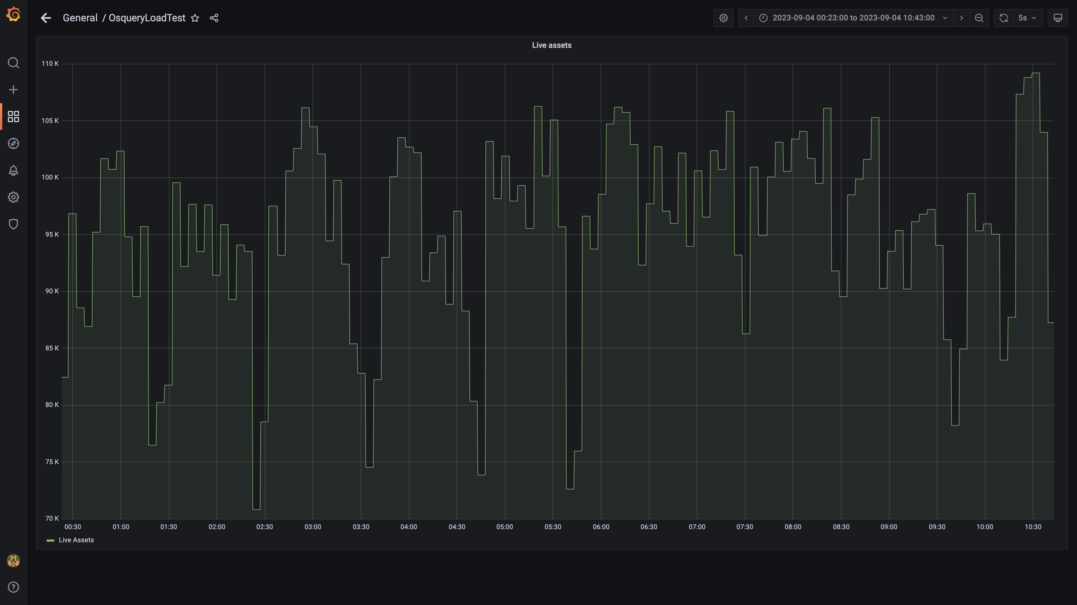

### Kafka lag for all groups

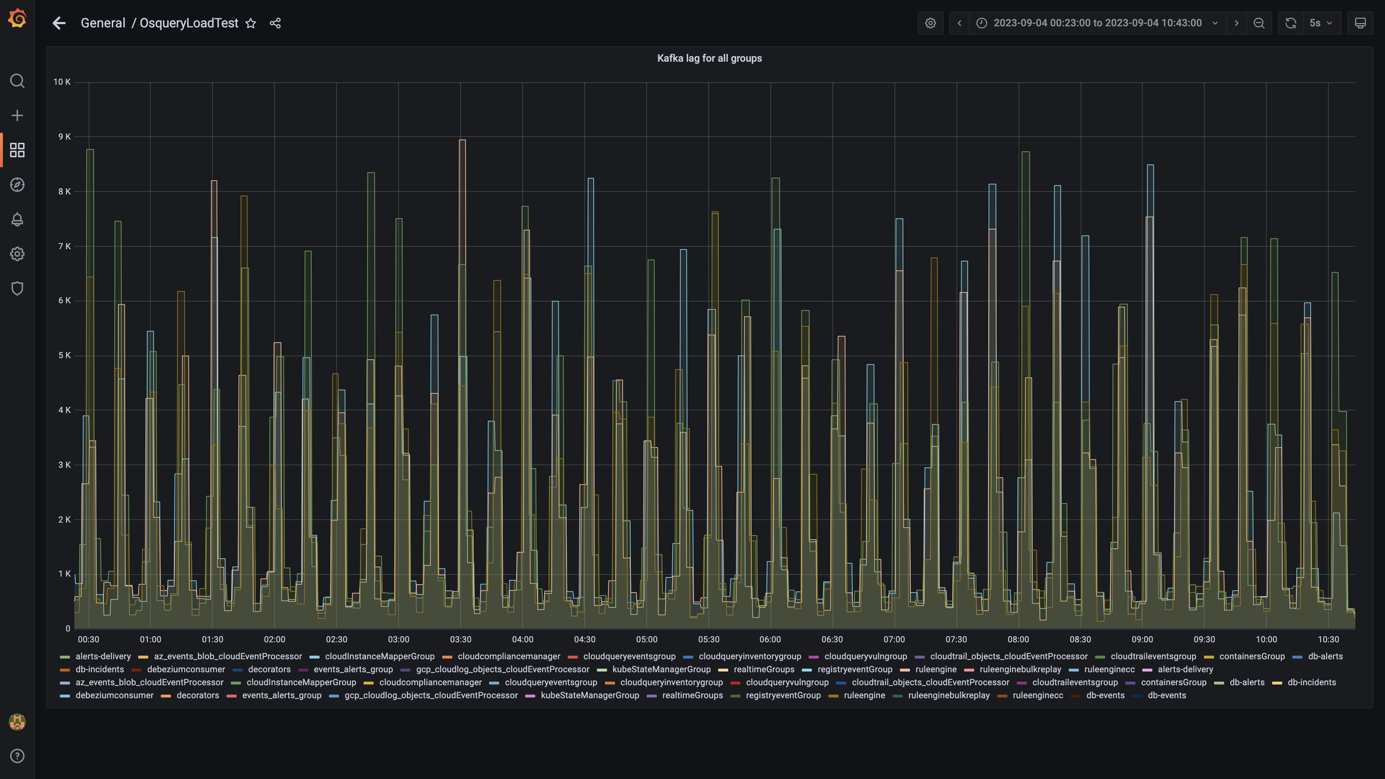

### Compaction status

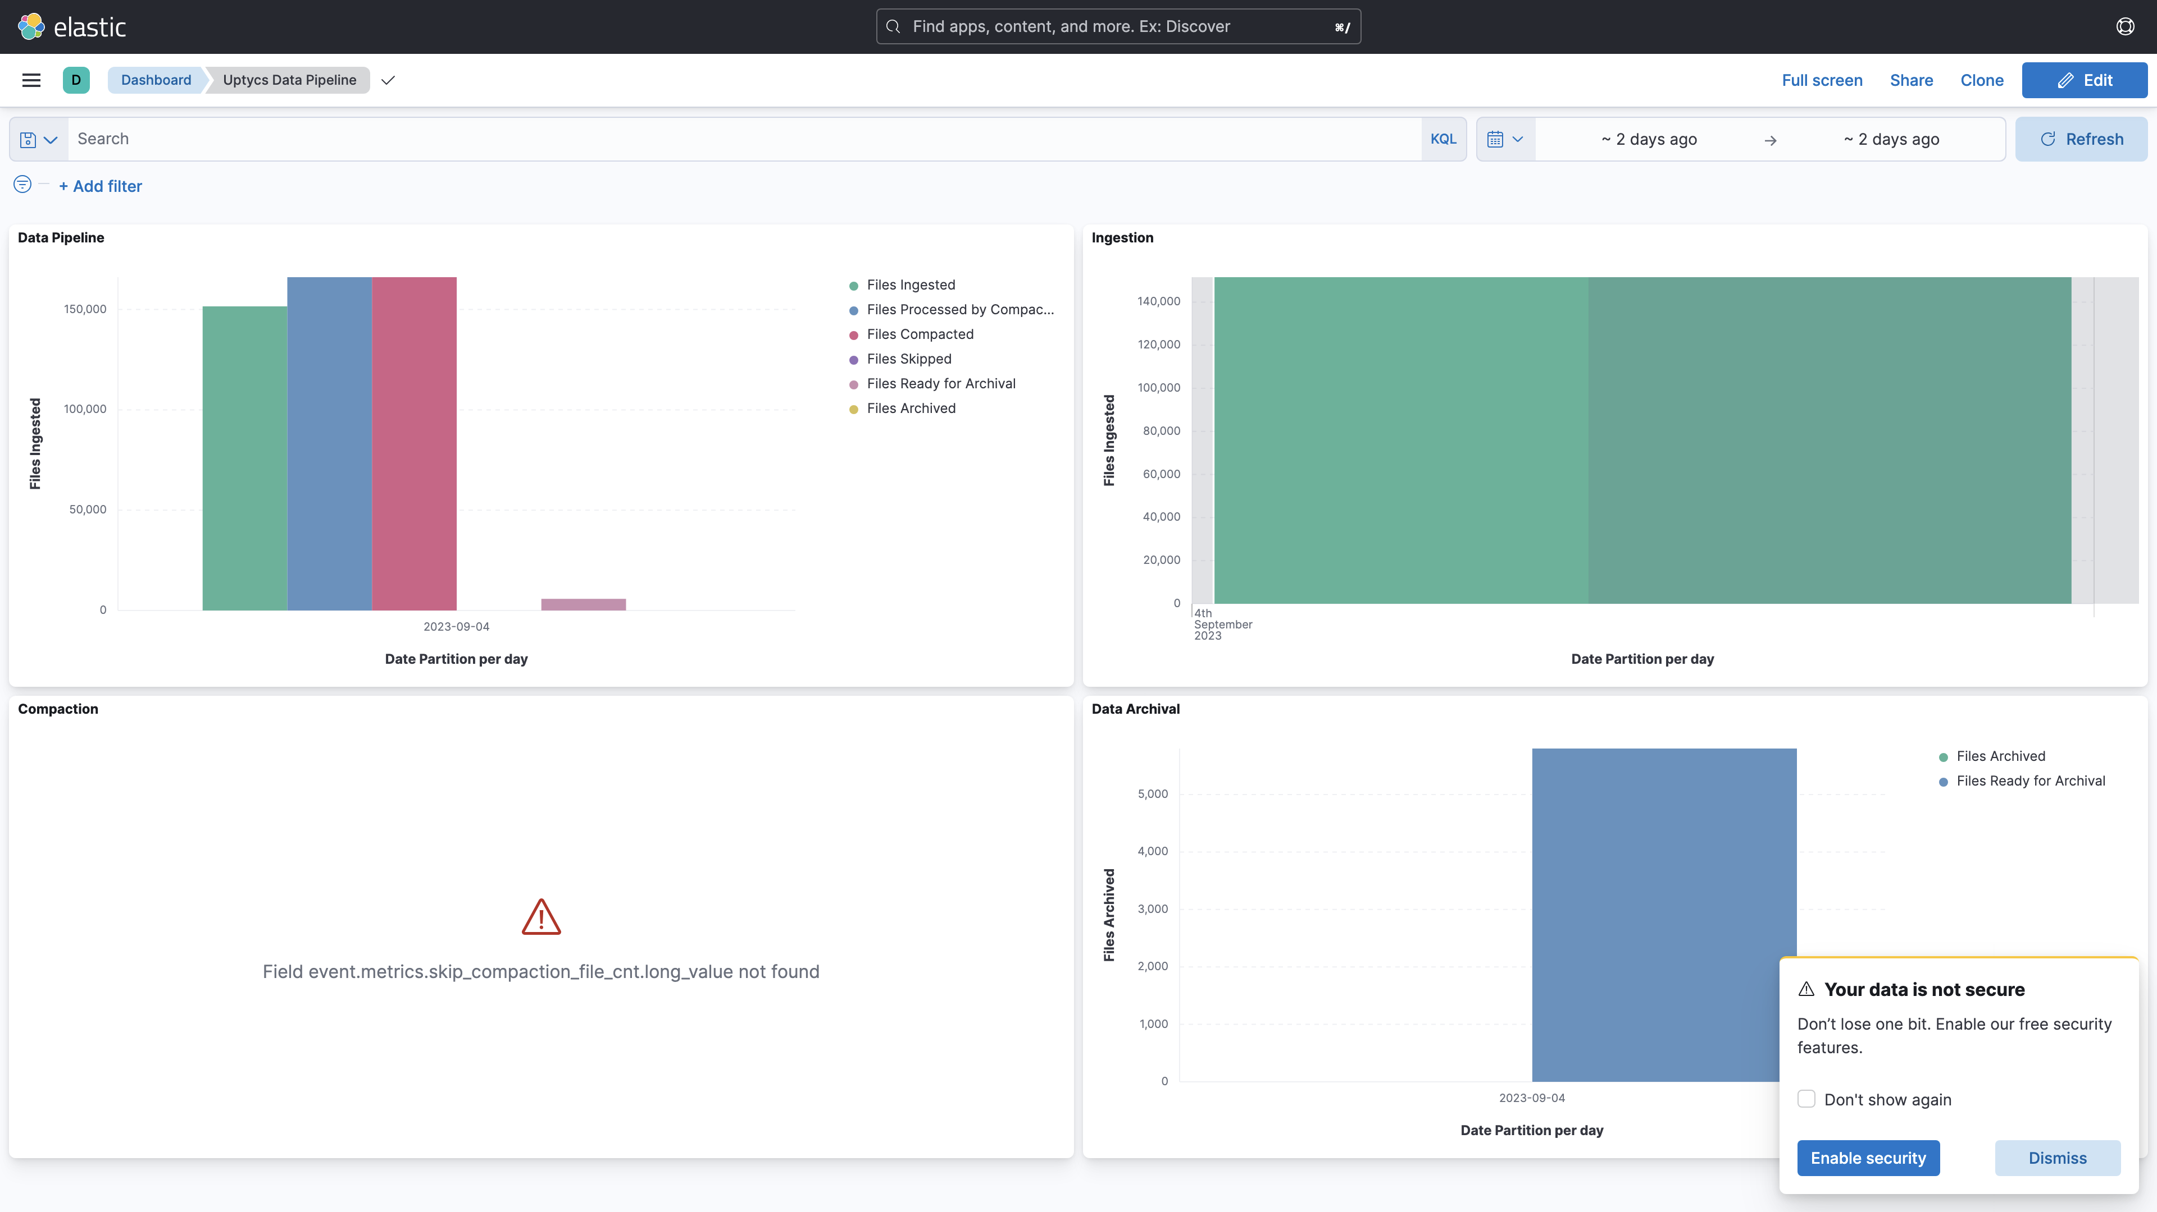

## Average Resource Utilization

### Comparision of Average Memory utilization

|  |  |  |  |  |
| --- | --- | --- | --- | --- |
| Metric | 137006 | 138005 | Absolute(%) | Relative(%) |
| Memory used by s1c1dn1 | 69.64% | 53.47% | 16.17% ⬇️ | 23.22% ⬇️ |
| Memory used by s1c1dn2 | 57.48% | 53.56% | 3.91% ⬇️ | 6.80% ⬇️ |
| Memory used by s1c1dn3 | 57.94% | 49.66% | 8.28% ⬇️ | 14.29% ⬇️ |
| Memory used by s1c1dn4 | 62.24% | 53.77% | 8.47% ⬇️ | 13.61% ⬇️ |
| Memory used by s1c1dn5 | 62.09% | 49.92% | 12.17% ⬇️ | 19.60% ⬇️ |
| Memory used by s1c1dn6 | 64.15% | 51.52% | 12.64% ⬇️ | 19.70% ⬇️ |
| Memory used by s1c1pn1 | 35.06% | 47.02% | 11.96% ⬆️ | 34.12% ⬆️ |
| Memory used by s1c1pn2 | 34.37% | 49.21% | 14.84% ⬆️ | 43.17% ⬆️ |
| Memory used by s1c1pn3 | 30.41% | 46.12% | 15.71% ⬆️ | 51.65% ⬆️ |
| Memory used by s1c1pn4 | 24.87% | 50.96% | 26.09% ⬆️ | 104.89% ⬆️ |
| Memory used by s1c1pn5 | 33.51% | 52.46% | 18.95% ⬆️ | 56.55% ⬆️ |
| Memory used by s1c1pn6 | 32.34% | 51.61% | 19.27% ⬆️ | 59.60% ⬆️ |
| Memory used by s1c2dn1 | 49.72% | 53.48% | 3.77% ⬆️ | 7.57% ⬆️ |
| Memory used by s1c2dn2 | 45.60% | 42.96% | 2.64% ⬇️ | 5.79% ⬇️ |
| Memory used by s1c2dn3 | 46.55% | 40.80% | 5.74% ⬇️ | 12.34% ⬇️ |
| Memory used by s1c2dn4 | 56.72% | 53.80% | 2.93% ⬇️ | 5.16% ⬇️ |
| Memory used by s1c2dn5 | 57.05% | 51.34% | 5.70% ⬇️ | 10.00% ⬇️ |
| Memory used by s1c2dn6 | 56.38% | 52.78% | 3.60% ⬇️ | 6.39% ⬇️ |
| Memory used by s1c2pn1 | 27.00% | 41.65% | 14.65% ⬆️ | 54.24% ⬆️ |
| Memory used by s1c2pn2 | 27.58% | 47.97% | 20.39% ⬆️ | 73.95% ⬆️ |
| Memory used by s1c2pn3 | 26.09% | 48.14% | 22.05% ⬆️ | 84.53% ⬆️ |
| Memory used by s1c2pn4 | 26.81% | 47.10% | 20.29% ⬆️ | 75.71% ⬆️ |
| Memory used by s1c2pn5 | 31.30% | 48.33% | 17.03% ⬆️ | 54.41% ⬆️ |
| Memory used by s1c2pn6 | 29.64% | 48.22% | 18.57% ⬆️ | 62.66% ⬆️ |
| Memory used by s1cloudquery | - | 3.81% | - | - |
| Memory used by s1configdb1 | 13.62% | 2.10% | 11.52% ⬇️ | 84.55% ⬇️ |
| Memory used by s1configdb2 | 1.20% | 13.74% | 12.54% ⬆️ | 1046.09% ⬆️ |
| Memory used by s1elasticsearch | - | 26.53% | - | - |
| Memory used by s1kibana | - | 4.39% | - | - |
| Memory used by s1logstash1 | - | 16.50% | - | - |
| Memory used by s1logstash2 | - | 16.51% | - | - |
| Memory used by s1mlnode1 | - | 12.90% | - | - |
| Memory used by s1mlnode2 | - | 6.43% | - | - |
| Memory used by s1monitor | 22.22% | 4.41% | 17.80% ⬇️ | 80.14% ⬇️ |
| Memory used by s1stsnode1 | - | 6.70% | - | - |
| Memory used by s1stsnode2 | - | 16.89% | - | - |
| Memory used by s1stsnode3 | - | 8.45% | - | - |
| Memory used by Rule Engine s1c1pn1 | 3.30% | 7.22% | 3.92% ⬆️ | 118.57% ⬆️ |
| Memory used by Rule Engine s1c1pn2 | 3.40% | 7.10% | 3.70% ⬆️ | 109.00% ⬆️ |
| Memory used by Rule Engine s1c1pn3 | 3.30% | 7.01% | 3.70% ⬆️ | 112.13% ⬆️ |
| Memory used by Rule Engine s1c1pn4 | 3.31% | 7.13% | 3.82% ⬆️ | 115.58% ⬆️ |
| Memory used by Rule Engine s1c1pn5 | 3.40% | 6.94% | 3.54% ⬆️ | 104.10% ⬆️ |
| Memory used by Rule Engine s1c1pn6 | 3.40% | 7.30% | 3.90% ⬆️ | 114.71% ⬆️ |
| Memory used by Rule Engine s1c2pn1 | 3.20% | 7.16% | 3.96% ⬆️ | 123.89% ⬆️ |
| Memory used by Rule Engine s1c2pn2 | 3.20% | 7.25% | 4.05% ⬆️ | 126.65% ⬆️ |
| Memory used by Rule Engine s1c2pn3 | 3.30% | 7.15% | 3.85% ⬆️ | 116.56% ⬆️ |
| Memory used by Rule Engine s1c2pn4 | 3.40% | 6.95% | 3.55% ⬆️ | 104.44% ⬆️ |
| Memory used by Rule Engine s1c2pn5 | 3.30% | 6.92% | 3.62% ⬆️ | 109.59% ⬆️ |
| Memory used by Rule Engine s1c2pn6 | 3.40% | 7.27% | 3.87% ⬆️ | 113.97% ⬆️ |
| Memory used by Osquery Ingestion s1c1dn1 | 5.55% | 6.74% | 1.20% ⬆️ | 21.56% ⬆️ |
| Memory used by Osquery Ingestion s1c1dn2 | 5.93% | 6.23% | 0.30% ⬆️ | 5.12% ⬆️ |
| Memory used by Osquery Ingestion s1c1dn3 | 6.11% | 6.76% | 0.65% ⬆️ | 10.62% ⬆️ |
| Memory used by Osquery Ingestion s1c1dn4 | 8.04% | 8.87% | 0.83% ⬆️ | 10.35% ⬆️ |
| Memory used by Osquery Ingestion s1c1dn5 | 8.59% | 8.73% | 0.15% ⬆️ | 1.72% ⬆️ |
| Memory used by Osquery Ingestion s1c1dn6 | 8.67% | 8.84% | 0.17% ⬆️ | 1.96% ⬆️ |
| Memory used by Osquery Ingestion s1c2dn1 | 4.86% | 6.18% | 1.32% ⬆️ | 27.21% ⬆️ |
| Memory used by Osquery Ingestion s1c2dn2 | 5.44% | 6.70% | 1.26% ⬆️ | 23.14% ⬆️ |
| Memory used by Osquery Ingestion s1c2dn3 | 6.01% | 6.78% | 0.77% ⬆️ | 12.80% ⬆️ |
| Memory used by Osquery Ingestion s1c2dn4 | 7.68% | 9.01% | 1.33% ⬆️ | 17.34% ⬆️ |
| Memory used by Osquery Ingestion s1c2dn5 | 7.89% | 8.82% | 0.93% ⬆️ | 11.79% ⬆️ |
| Memory used by Osquery Ingestion s1c2dn6 | 7.61% | 8.75% | 1.14% ⬆️ | 14.99% ⬆️ |
| Memory used by Kafka s1c1pn1 | 3.04% | 2.82% | 0.23% ⬇️ | 7.46% ⬇️ |
| Memory used by Kafka s1c1pn2 | 3.30% | 3.31% | 0.01% ⬆️ | 0.25% ⬆️ |
| Memory used by Kafka s1c1pn3 | 3.42% | 3.30% | 0.12% ⬇️ | 3.62% ⬇️ |
| Memory used by Kafka s1c1pn4 | 3.45% | 3.36% | 0.08% ⬇️ | 2.39% ⬇️ |
| Memory used by Kafka s1c1pn5 | 3.40% | 3.38% | 0.02% ⬇️ | 0.49% ⬇️ |
| Memory used by Kafka s1c1pn6 | 3.36% | 3.38% | 0.02% ⬆️ | 0.74% ⬆️ |
| Memory used by Kafka s1c2pn1 | 2.67% | 2.93% | 0.26% ⬆️ | 9.81% ⬆️ |
| Memory used by Kafka s1c2pn2 | 3.14% | 3.40% | 0.26% ⬆️ | 8.14% ⬆️ |
| Memory used by Kafka s1c2pn3 | 3.12% | 3.40% | 0.28% ⬆️ | 8.93% ⬆️ |
| Memory used by Kafka s1c2pn4 | 3.01% | 3.37% | 0.37% ⬆️ | 12.27% ⬆️ |
| Memory used by Kafka s1c2pn5 | 3.17% | 3.40% | 0.23% ⬆️ | 7.25% ⬆️ |
| Memory used by Kafka s1c2pn6 | 3.07% | 3.32% | 0.25% ⬆️ | 8.02% ⬆️ |
| Memory used by Trino s1c1dn1 | 22.41% | 11.08% | 11.33% ⬇️ | 50.56% ⬇️ |
| Memory used by Trino s1c1dn2 | 15.33% | 15.10% | 0.23% ⬇️ | 1.47% ⬇️ |
| Memory used by Trino s1c1dn3 | 15.70% | 14.50% | 1.20% ⬇️ | 7.63% ⬇️ |
| Memory used by Trino s1c1dn4 | 15.86% | 15.40% | 0.46% ⬇️ | 2.88% ⬇️ |
| Memory used by Trino s1c1dn5 | 16.19% | 15.20% | 0.99% ⬇️ | 6.10% ⬇️ |
| Memory used by Trino s1c1dn6 | 16.29% | 14.90% | 1.39% ⬇️ | 8.55% ⬇️ |
| Memory used by Trino s1c2dn1 | 15.45% | 24.35% | 8.90% ⬆️ | 57.56% ⬆️ |
| Memory used by Trino s1c2dn2 | 15.31% | 16.39% | 1.09% ⬆️ | 7.11% ⬆️ |
| Memory used by Trino s1c2dn3 | 15.51% | 16.29% | 0.78% ⬆️ | 5.02% ⬆️ |
| Memory used by Trino s1c2dn4 | 16.23% | 17.69% | 1.46% ⬆️ | 8.99% ⬆️ |
| Memory used by Trino s1c2dn5 | 16.14% | 17.38% | 1.25% ⬆️ | 7.73% ⬆️ |
| Memory used by Trino s1c2dn6 | 16.01% | 17.49% | 1.48% ⬆️ | 9.23% ⬆️ |
| Memory used by Tls s1c1pn1 | 0.34% | 0.74% | 0.40% ⬆️ | 120.19% ⬆️ |
| Memory used by Tls s1c1pn2 | 0.34% | 0.72% | 0.39% ⬆️ | 114.49% ⬆️ |
| Memory used by Tls s1c1pn3 | 0.34% | 0.77% | 0.43% ⬆️ | 127.68% ⬆️ |
| Memory used by Tls s1c1pn4 | 0.34% | 0.76% | 0.42% ⬆️ | 124.81% ⬆️ |
| Memory used by Tls s1c1pn5 | 0.33% | 0.79% | 0.46% ⬆️ | 137.12% ⬆️ |
| Memory used by Tls s1c1pn6 | 0.34% | 0.80% | 0.46% ⬆️ | 133.71% ⬆️ |
| Memory used by Tls s1c2pn1 | 0.34% | 0.77% | 0.43% ⬆️ | 125.31% ⬆️ |
| Memory used by Tls s1c2pn2 | 0.34% | 0.76% | 0.42% ⬆️ | 125.71% ⬆️ |
| Memory used by Tls s1c2pn3 | 0.34% | 0.79% | 0.45% ⬆️ | 132.76% ⬆️ |
| Memory used by Tls s1c2pn4 | 0.34% | 0.76% | 0.42% ⬆️ | 123.05% ⬆️ |
| Memory used by Tls s1c2pn5 | 0.34% | 0.84% | 0.50% ⬆️ | 148.05% ⬆️ |
| Memory used by Tls s1c2pn6 | 0.34% | 0.83% | 0.49% ⬆️ | 144.77% ⬆️ |
| Memory used by Logger s1c1pn4 | - | 0.47% | - | - |
| Memory used by Logger s1c1pn5 | - | 0.44% | - | - |
| Memory used by Logger s1c1pn6 | - | 0.46% | - | - |
| Memory used by Logger s1c2pn2 | - | 0.40% | - | - |
| Memory used by Logger s1c2pn3 | - | 0.46% | - | - |
| Memory used by Logger s1c2pn4 | - | 0.49% | - | - |
| Memory used by Logger s1c2pn5 | - | 0.34% | - | - |
| Memory used by Logger s1c2pn6 | - | 0.36% | - | - |

### Comparision of Average CPU utilization

|  |  |  |  |  |
| --- | --- | --- | --- | --- |
| Metric | 137006 | 138005 | Absolute(%) | Relative(%) |
| CPU used by s1c1dn1 | 44.48% | 15.18% | 29.30% ⬇️ | 65.87% ⬇️ |
| CPU used by s1c1dn2 | 44.05% | 15.15% | 28.90% ⬇️ | 65.61% ⬇️ |
| CPU used by s1c1dn3 | 40.41% | 13.46% | 26.94% ⬇️ | 66.68% ⬇️ |
| CPU used by s1c1dn4 | 40.57% | 13.29% | 27.28% ⬇️ | 67.24% ⬇️ |
| CPU used by s1c1dn5 | 41.54% | 14.50% | 27.03% ⬇️ | 65.08% ⬇️ |
| CPU used by s1c1dn6 | 41.73% | 15.19% | 26.53% ⬇️ | 63.59% ⬇️ |
| CPU used by s1c1pn1 | 68.07% | 39.69% | 28.38% ⬇️ | 41.69% ⬇️ |
| CPU used by s1c1pn2 | 57.02% | 48.40% | 8.61% ⬇️ | 15.11% ⬇️ |
| CPU used by s1c1pn3 | 62.34% | 45.97% | 16.37% ⬇️ | 26.26% ⬇️ |
| CPU used by s1c1pn4 | 51.37% | 62.17% | 10.80% ⬆️ | 21.01% ⬆️ |
| CPU used by s1c1pn5 | 61.02% | 62.01% | 0.99% ⬆️ | 1.62% ⬆️ |
| CPU used by s1c1pn6 | 57.78% | 61.69% | 3.91% ⬆️ | 6.77% ⬆️ |
| CPU used by s1c2dn1 | 42.29% | 15.49% | 26.80% ⬇️ | 63.38% ⬇️ |
| CPU used by s1c2dn2 | 38.98% | 12.84% | 26.13% ⬇️ | 67.05% ⬇️ |
| CPU used by s1c2dn3 | 38.83% | 12.97% | 25.86% ⬇️ | 66.59% ⬇️ |
| CPU used by s1c2dn4 | 38.23% | 12.78% | 25.45% ⬇️ | 66.57% ⬇️ |
| CPU used by s1c2dn5 | 39.55% | 16.40% | 23.15% ⬇️ | 58.53% ⬇️ |
| CPU used by s1c2dn6 | 40.09% | 12.71% | 27.38% ⬇️ | 68.31% ⬇️ |
| CPU used by s1c2pn1 | 54.10% | 46.50% | 7.60% ⬇️ | 14.05% ⬇️ |
| CPU used by s1c2pn2 | 48.50% | 61.06% | 12.56% ⬆️ | 25.89% ⬆️ |
| CPU used by s1c2pn3 | 49.26% | 63.15% | 13.88% ⬆️ | 28.18% ⬆️ |
| CPU used by s1c2pn4 | 53.12% | 62.30% | 9.18% ⬆️ | 17.29% ⬆️ |
| CPU used by s1c2pn5 | 51.55% | 61.89% | 10.34% ⬆️ | 20.07% ⬆️ |
| CPU used by s1c2pn6 | 59.01% | 63.53% | 4.52% ⬆️ | 7.65% ⬆️ |
| CPU used by s1cloudquery | - | 6.93% | - | - |
| CPU used by s1configdb1 | 19.69% | 1.84% | 17.85% ⬇️ | 90.66% ⬇️ |
| CPU used by s1configdb2 | 4.83% | 96.60% | 91.78% ⬆️ | 1900.90% ⬆️ |
| CPU used by s1elasticsearch | - | 4.90% | - | - |
| CPU used by s1kibana | - | 4.98% | - | - |
| CPU used by s1logstash1 | - | 13.57% | - | - |
| CPU used by s1logstash2 | - | 13.60% | - | - |
| CPU used by s1mlnode1 | - | 11.26% | - | - |
| CPU used by s1mlnode2 | - | 6.43% | - | - |
| CPU used by s1monitor | 4.43% | 1.87% | 2.56% ⬇️ | 57.77% ⬇️ |
| CPU used by s1stsnode1 | - | 2.84% | - | - |
| CPU used by s1stsnode2 | - | 3.18% | - | - |
| CPU used by s1stsnode3 | - | 2.89% | - | - |
| CPU used by Rule Engine s1c1pn1 | 8.32% | 25.57% | 17.25% ⬆️ | 207.33% ⬆️ |
| CPU used by Rule Engine s1c1pn2 | 7.06% | 24.03% | 16.97% ⬆️ | 240.23% ⬆️ |
| CPU used by Rule Engine s1c1pn3 | 7.71% | 19.20% | 11.49% ⬆️ | 149.08% ⬆️ |
| CPU used by Rule Engine s1c1pn4 | 6.22% | 14.77% | 8.55% ⬆️ | 137.51% ⬆️ |
| CPU used by Rule Engine s1c1pn5 | 7.31% | 16.77% | 9.46% ⬆️ | 129.34% ⬆️ |
| CPU used by Rule Engine s1c1pn6 | 6.84% | 16.50% | 9.66% ⬆️ | 141.24% ⬆️ |
| CPU used by Rule Engine s1c2pn1 | 7.38% | 18.29% | 10.92% ⬆️ | 147.94% ⬆️ |
| CPU used by Rule Engine s1c2pn2 | 6.81% | 18.76% | 11.95% ⬆️ | 175.53% ⬆️ |
| CPU used by Rule Engine s1c2pn3 | 6.41% | 16.78% | 10.36% ⬆️ | 161.54% ⬆️ |
| CPU used by Rule Engine s1c2pn4 | 7.50% | 18.26% | 10.76% ⬆️ | 143.45% ⬆️ |
| CPU used by Rule Engine s1c2pn5 | 6.96% | 16.13% | 9.17% ⬆️ | 131.70% ⬆️ |
| CPU used by Rule Engine s1c2pn6 | 7.72% | 16.55% | 8.83% ⬆️ | 114.28% ⬆️ |
| CPU used by Osquery Ingestion s1c1dn1 | 32.57% | 28.27% | 4.30% ⬇️ | 13.20% ⬇️ |
| CPU used by Osquery Ingestion s1c1dn2 | 40.21% | 20.55% | 19.67% ⬇️ | 48.90% ⬇️ |
| CPU used by Osquery Ingestion s1c1dn3 | 39.83% | 31.45% | 8.38% ⬇️ | 21.03% ⬇️ |
| CPU used by Osquery Ingestion s1c1dn4 | 35.39% | 35.38% | 0.01% ⬇️ | 0.03% ⬇️ |
| CPU used by Osquery Ingestion s1c1dn5 | 38.51% | 32.82% | 5.69% ⬇️ | 14.78% ⬇️ |
| CPU used by Osquery Ingestion s1c1dn6 | 42.98% | 31.51% | 11.46% ⬇️ | 26.67% ⬇️ |
| CPU used by Osquery Ingestion s1c2dn1 | 20.51% | 28.83% | 8.31% ⬆️ | 40.53% ⬆️ |
| CPU used by Osquery Ingestion s1c2dn2 | 45.97% | 30.82% | 15.15% ⬇️ | 32.96% ⬇️ |
| CPU used by Osquery Ingestion s1c2dn3 | 44.76% | 33.37% | 11.38% ⬇️ | 25.44% ⬇️ |
| CPU used by Osquery Ingestion s1c2dn4 | 38.96% | 28.63% | 10.34% ⬇️ | 26.53% ⬇️ |
| CPU used by Osquery Ingestion s1c2dn5 | 36.77% | 33.18% | 3.59% ⬇️ | 9.77% ⬇️ |
| CPU used by Osquery Ingestion s1c2dn6 | 40.65% | 31.24% | 9.40% ⬇️ | 23.13% ⬇️ |
| CPU used by Kafka s1c1pn1 | 136.31% | 44.30% | 92.01% ⬇️ | 67.50% ⬇️ |
| CPU used by Kafka s1c1pn2 | 86.20% | 89.48% | 3.28% ⬆️ | 3.81% ⬆️ |
| CPU used by Kafka s1c1pn3 | 101.24% | 43.41% | 57.82% ⬇️ | 57.12% ⬇️ |
| CPU used by Kafka s1c1pn4 | 85.09% | 52.15% | 32.95% ⬇️ | 38.72% ⬇️ |
| CPU used by Kafka s1c1pn5 | 201.71% | 52.22% | 149.49% ⬇️ | 74.11% ⬇️ |
| CPU used by Kafka s1c1pn6 | 217.75% | 44.48% | 173.27% ⬇️ | 79.57% ⬇️ |
| CPU used by Kafka s1c2pn1 | 75.29% | 46.40% | 28.88% ⬇️ | 38.37% ⬇️ |
| CPU used by Kafka s1c2pn2 | 56.84% | 44.38% | 12.46% ⬇️ | 21.91% ⬇️ |
| CPU used by Kafka s1c2pn3 | 57.21% | 42.03% | 15.18% ⬇️ | 26.53% ⬇️ |
| CPU used by Kafka s1c2pn4 | 76.18% | 44.64% | 31.55% ⬇️ | 41.41% ⬇️ |
| CPU used by Kafka s1c2pn5 | 100.07% | 48.89% | 51.18% ⬇️ | 51.14% ⬇️ |
| CPU used by Kafka s1c2pn6 | 248.64% | 85.97% | 162.67% ⬇️ | 65.42% ⬇️ |
| CPU used by Trino s1c1dn1 | 49.67% | 4.35% | 45.32% ⬇️ | 91.24% ⬇️ |
| CPU used by Trino s1c1dn2 | 49.80% | 4.67% | 45.13% ⬇️ | 90.62% ⬇️ |
| CPU used by Trino s1c1dn3 | 51.21% | 3.01% | 48.20% ⬇️ | 94.12% ⬇️ |
| CPU used by Trino s1c1dn4 | 52.65% | 3.12% | 49.54% ⬇️ | 94.08% ⬇️ |
| CPU used by Trino s1c1dn5 | 52.33% | 2.87% | 49.46% ⬇️ | 94.52% ⬇️ |
| CPU used by Trino s1c1dn6 | 56.03% | 3.50% | 52.52% ⬇️ | 93.75% ⬇️ |
| CPU used by Trino s1c2dn1 | 52.90% | 28.66% | 24.23% ⬇️ | 45.81% ⬇️ |
| CPU used by Trino s1c2dn2 | 50.07% | 19.46% | 30.61% ⬇️ | 61.13% ⬇️ |
| CPU used by Trino s1c2dn3 | 50.87% | 18.71% | 32.16% ⬇️ | 63.22% ⬇️ |
| CPU used by Trino s1c2dn4 | 50.90% | 19.90% | 31.00% ⬇️ | 60.90% ⬇️ |
| CPU used by Trino s1c2dn5 | 51.88% | 19.24% | 32.64% ⬇️ | 62.92% ⬇️ |
| CPU used by Trino s1c2dn6 | 52.79% | 19.50% | 33.28% ⬇️ | 63.05% ⬇️ |
| CPU used by Tls s1c1pn1 | 142.56% | 87.50% | 55.07% ⬇️ | 38.63% ⬇️ |
| CPU used by Tls s1c1pn2 | 136.36% | 91.99% | 44.37% ⬇️ | 32.54% ⬇️ |
| CPU used by Tls s1c1pn3 | 151.02% | 92.97% | 58.04% ⬇️ | 38.44% ⬇️ |
| CPU used by Tls s1c1pn4 | 135.15% | 91.83% | 43.33% ⬇️ | 32.06% ⬇️ |
| CPU used by Tls s1c1pn5 | 135.93% | 91.58% | 44.35% ⬇️ | 32.63% ⬇️ |
| CPU used by Tls s1c1pn6 | 137.47% | 91.70% | 45.77% ⬇️ | 33.29% ⬇️ |
| CPU used by Tls s1c2pn1 | 135.52% | 89.80% | 45.72% ⬇️ | 33.74% ⬇️ |
| CPU used by Tls s1c2pn2 | 128.77% | 91.09% | 37.68% ⬇️ | 29.26% ⬇️ |
| CPU used by Tls s1c2pn3 | 131.88% | 101.98% | 29.91% ⬇️ | 22.68% ⬇️ |
| CPU used by Tls s1c2pn4 | 140.54% | 95.66% | 44.88% ⬇️ | 31.94% ⬇️ |
| CPU used by Tls s1c2pn5 | 134.87% | 93.78% | 41.09% ⬇️ | 30.46% ⬇️ |
| CPU used by Tls s1c2pn6 | 139.76% | 97.00% | 42.75% ⬇️ | 30.59% ⬇️ |
| CPU used by Logger s1c1pn1 | 23.12% | 4.32% | 18.80% ⬇️ | 81.30% ⬇️ |
| CPU used by Logger s1c1pn2 | 25.85% | 6.23% | 19.62% ⬇️ | 75.90% ⬇️ |
| CPU used by Logger s1c1pn3 | 17.92% | 6.22% | 11.69% ⬇️ | 65.26% ⬇️ |
| CPU used by Logger s1c1pn4 | 6.08% | 8.99% | 2.90% ⬆️ | 47.68% ⬆️ |
| CPU used by Logger s1c1pn5 | 17.64% | 8.26% | 9.38% ⬇️ | 53.16% ⬇️ |
| CPU used by Logger s1c1pn6 | 15.50% | 8.56% | 6.94% ⬇️ | 44.79% ⬇️ |
| CPU used by Logger s1c2pn1 | 10.70% | 7.00% | 3.71% ⬇️ | 34.64% ⬇️ |
| CPU used by Logger s1c2pn2 | 21.49% | 7.56% | 13.93% ⬇️ | 64.81% ⬇️ |
| CPU used by Logger s1c2pn3 | 16.86% | 8.26% | 8.60% ⬇️ | 51.00% ⬇️ |
| CPU used by Logger s1c2pn4 | 25.14% | 8.84% | 16.30% ⬇️ | 64.85% ⬇️ |
| CPU used by Logger s1c2pn5 | 11.81% | 6.20% | 5.60% ⬇️ | 47.47% ⬇️ |
| CPU used by Logger s1c2pn6 | 17.68% | 6.53% | 11.16% ⬇️ | 63.09% ⬇️ |

## Overall Usages

### Comparision of Overall Memory utilization

|  |  |  |  |
| --- | --- | --- | --- |
| Metric | 137006 | 138005 | Delta |
| Average Memory used by pnodes | 674.87 GB | 1088.10 GB | 61.23% (413.23 GB) ⬆️ |
| Average Memory used by dnodes | 1494.82 GB | 1326.48 GB | 11.26% (168.34 GB) ⬇️ |
| Average Memory used by pgnodes | 27.86 GB | 29.78 GB | 6.90% (1.92 GB) ⬆️ |

### Comparision of Overall CPU utilization

|  |  |  |  |
| --- | --- | --- | --- |
| Metric | 137006 | 138005 | Delta |
| Average CPU used by pnodes | 215.41 cores | 217.07 cores | 0.77% (1.67 cores) ⬆️ |
| Average CPU used by dnodes | 157.04 cores | 54.39 cores | 65.36% (102.65 cores) ⬇️ |
| Average CPU used by pgnodes | 7.84 cores | 31.50 cores | 301.60% (23.66 cores) ⬆️ |